E-Commerce Project Steps:

**Set-up:**

**Other way:**

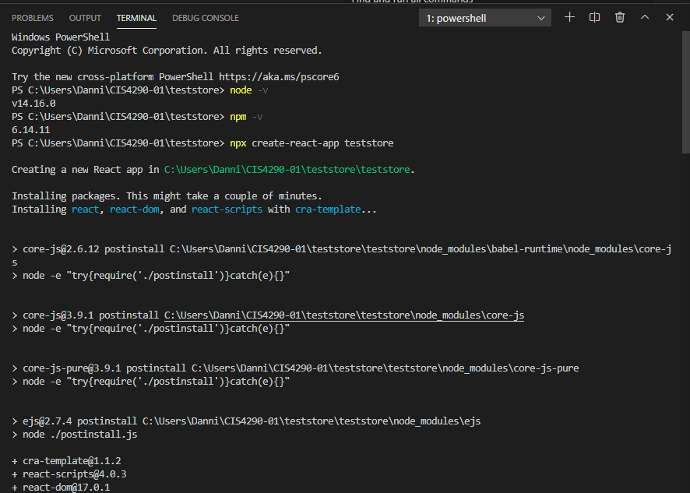

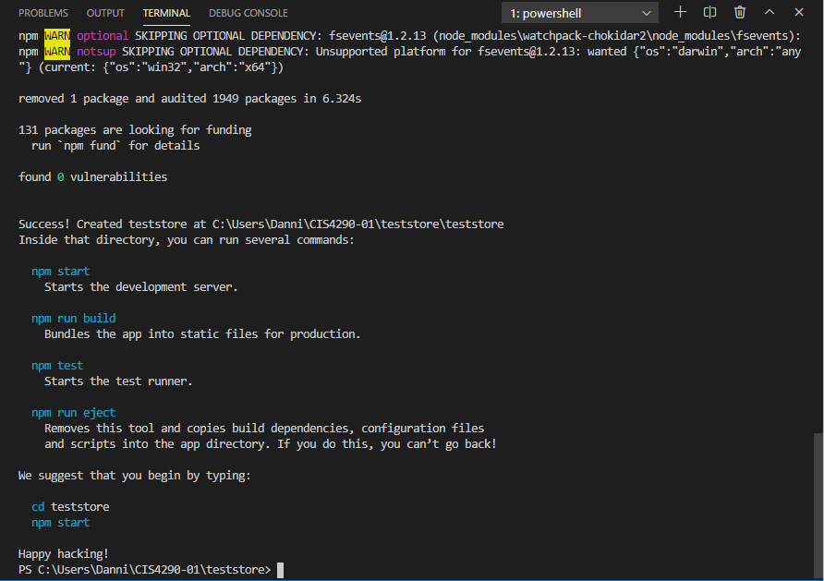

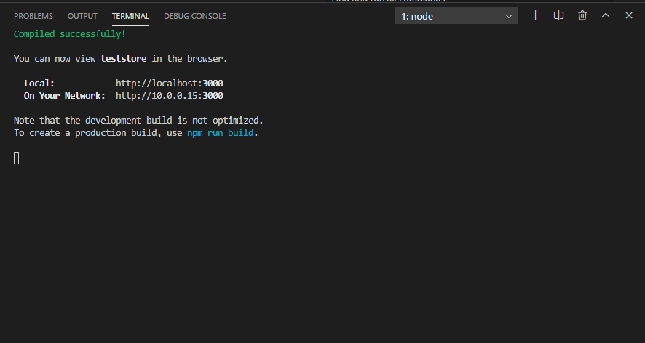

**Make sure you have Node.js installed in your computer!**

**Do not use capital letter for the folder!**

Step1: Create a new folder called “YourProjecct” and open it in blank visual studio code

Step2: After the folder has been opened in VS, click “View” -> “Terminal”

Step3: In the terminal, input [ npx create-react-app ./] and “enter”

*If your system running is showing error, please input [npx create-react-app my-app]

<!—this is going to initialize a new react application inside of the folder -- >

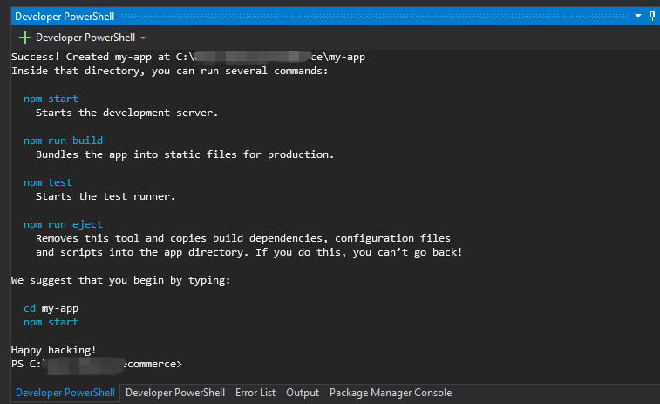

Step4: Install all the necessary dependencies

Create the new terminal for this; --clear

PS C:\Users\Danni\CIS4290-01\teststore> cd teststore

PS C:\Users\Danni\CIS4290-01\teststore\teststore> npm install @material-ui/core @material-ui/icons @chec/commerce.js @stripe/react-stripe-js @stripe/stripe-js react-router-dom react-hook-form

Step5: After install the js, delete the src folder and create the new folder called “src”

Step6: In the “src.folder”, create a new “index.js”

**Index.js set-up:**

Step1: input

[

import React from 'react';

import ReactDOM from 'react-dom';

import App from './App';

ReactDOM.render(<App />, document.getElementById('root'));

]

Step2: go to “public.folder” -> open “index.html” and changed the title name

Step3: In the “src.folder”, create a new “App.js”

**App.js set-up:**

Step1: input[

import React from 'react'

const App = () => {

    return(

        <div>

        </div>

    )

    }

    export default App

Step2: on the terminal, type “npm start”

<!-- The browser will automatically start run if you already install the extension “ES7”-->

**Layout Setup:**

Step1: Create new folder under “src” called “components”

Step2: Create a “product” folder inside the “components” folder

Step3: Create a file “Products.jsx” inside the “product” folder